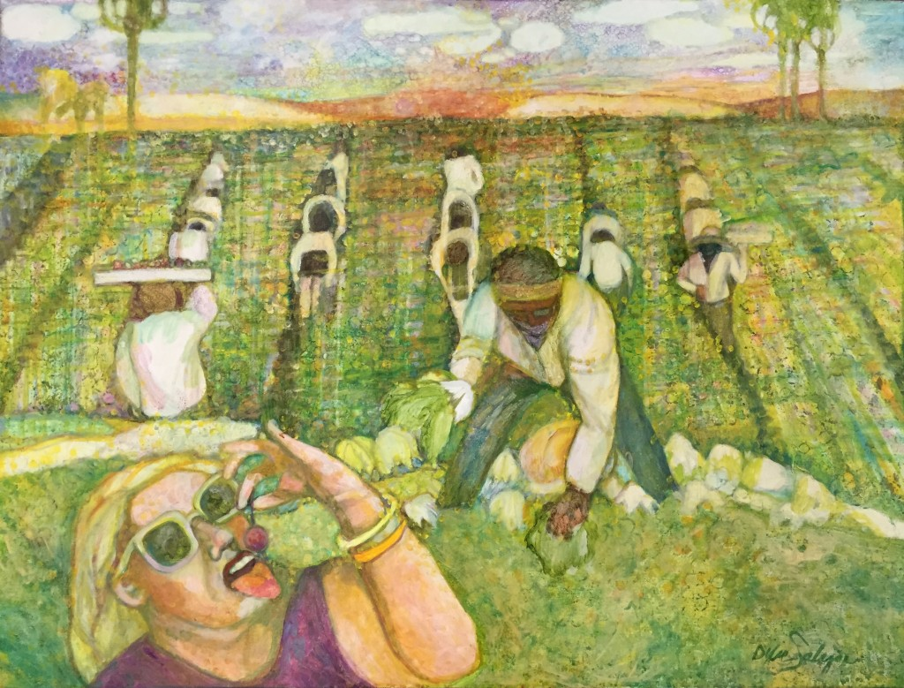

ARTS ALIVE in AGRICULTURE

Annual Competition and Exhibition
The Fresno Arts Council will honor the rich cultural tradition and everyday practices of agriculture and farming in the Central Valley by hosting the 2015 SPRING JURIED ART EXHIBITION AND COMPETITION. Enter on-line: http://fresnoartscouncil.org/arts-alive-in-agriculture-annual-competition-and-exhibition/
EXHIBIT DATE: May 7th,2015
LOCATION: Fresno City Hall
OPENING RECEPTION: Thursday, May 7th
CASH PRIZES WILL BE AWARDED
2015 PROSPECTUS:
The ARTS ALIVE in AGRICULTURE EXHIBITION AND COMPETITION is an event to showcase and celebrate the admirable attributes of our community tradition and resources. The Central Valley is rich fertile land that covers the central portion of the State of California. Surrounded by the Sierra Nevada, Cascade and Tehachapi Mountain ranges, the central Valley is one the world’s most fruitful regions where nearly all non-tropical crops are grown. THE FRESNO ARTS COUNCIL seeks to highlight the agricultural industry by showing thoughtful and compelling works from artists from the central valley. The 2015 ART SHOW will feature mixed-media works in: painting, sculpture, photography and found objects.
CALL FOR ENTRIES OPEN: January 31 thru April 5th 2015.
ELIGIBILITY:
Open to all artist who reside in the Central Valley 18 years or older.
CATAGORIES OF ENTRIES INCLUDE:
- The Human Component of Agriculture
- Technology and Machinery of Agriculture
- Agricultural Landscapes

SUBMISSION GUIDELINES:
MEDIA: Art media in painting, sculpture, photography, and found objects may be submitted in any and all categories.

RULES OF ENTRY:
Submit a one page cover sheet for all entries, include your contact information: name, address, telephones (cell, work & home), your e-mail and website addresses. Description of artwork: media, style, dimensions and general subject matter.
Works submitted must have been completed in the last two years, cannot be a copy.
Photographic images: Judging will be done in two categories, Documentary: basic image management without manipulations of subject matter. Interpretive: involving manipulation of subject matter.
Artwork: must be submitted dry, framed, securely wired and ready to hang, acrylic rather than glass for covering work is preferred, framing must be simple and not heavy.
Each work cannot be taller than 34”; the length should not be wider that 54”.
Each work cannot weight over 50 lbs.
3D Pieces: must be at least 8 inches in any direction (for safety purposes)
No accepted works can be removed before the completion of the show.
Works must be available for purchase with 30% commission on all sales.
Entrants will be notified of their acceptance on April 22, 2015. Final exhibit details will be available at that time. Additionally, submission of a brief artists bio (100 words or less), and a FAC release of liability form will need to be signed at this time.
SUBMISSION OF ONLINE DIGITAL IMAGE GUIDELINES:
Full size, no larger than 2mb, 72 dpi resolution
Sized to 1280 pixels
JPG format
JPG compression quality: medium
File name consists of: your name, underscore, first name, underscore and title of work.
(Ex: Smith_Art_The Flight)
ENTRY FEE: $30.00, 2 works $40.00, 3 works $50.00 PANEL OF JURORS:
Jurors of the 2015 Spring Arts Alive in Agriculture show will be conducted by qualified artists and patrons in the field of agriculture and the arts.
CASH PRIZES WILL BE AWARDED
QUESTIONS OR ADDED INFORMATION:
Contact: Lilia Gonzales Chavez (lilia@fresnoartscouncil.org) or Julian Ramos (julian@fresnoartscouncil.org) at Fresno Arts Council 559-237-9734 or visit www.fresnoartscouncil.org

